
The City of Markham has received a complete Zoning By-law Amendment Application, for 9421 and 9441 Markham Road submitted by Malone Given Parsons Ltd. (Rohan Sovig) on February 9, 2026. As the owner of land within 200 m of the property, you are invited to participate in the review process.
MappiT
Tell us what you think!
A statutory Public Meeting to consider the applicant’s proposal will take place on:
Meeting Date: | April 7, 2026
Time: | 7:00 pm
Place: | Members of the Development Services Committee will participate in a statutory Public Meeting remotely (Zoom link) and in person (Council Chamber) at:  Markham Civic Centre  101 Town Centre Boulevard  Markham, ON L3R 9W3  All proceedings of this meeting are recorded, and video and audio streamed on the City’s website at pub-markham.escribemeetings.com.
The Property
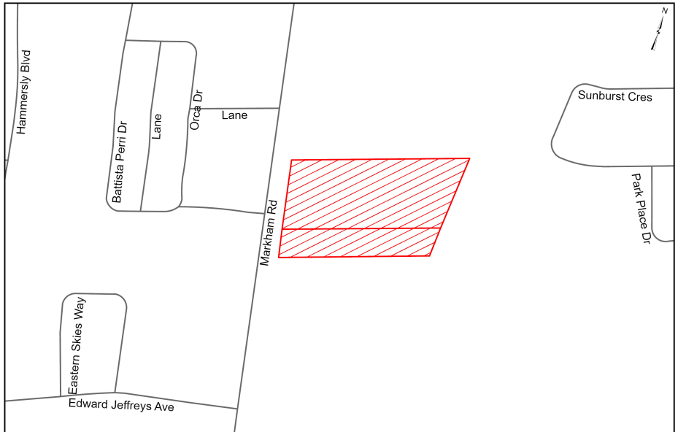
The 1.46 ha (3.60 ac) subject lands, municipally known as 9421 and 9441 Markham Road, are located on the east side of Markham Road, south of Bur Oak Avenue. The subject lands are currently occupied by a one storey commercial building, which includes a place of worship.
The Applicant’s Proposal
The Owner has made a Zoning By-law Amendment application to allow for three mixed-use buildings ranging in height from 30-35 storeys with a total of 1,218 residential units. The application also includes a new public road and a 0.15 ha (0.37 ac) public park.


Additional Information
PMIR
For additional information on 26 108916 000 00 PLAN, scan this to access the Public Meeting Information Report (PMIR).
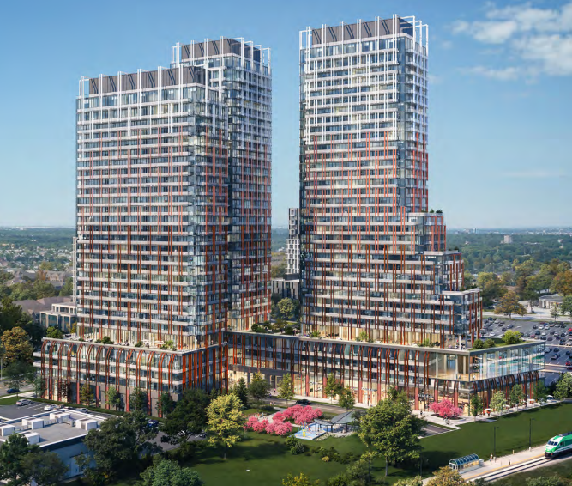

Connect with the File Planner
File Planner: | Hailey Miller, Senior Planner
File Planner Email: | hmiller@markham.ca
File Planner Phone: | (905) 477-7000, 2945
File Number: | Refer to application number 26 108916 000 00 PLAN
Join the conversation!
Request to Speak (Deputations)
Any request to speak may be made to the Clerks Department up to the start of the statutory Public Meeting, and by one or all the following:
- Complete the “Request to Speak” form located online at markham.ca
- Email the City at notifications@markham.ca
- Call (905) 477-7760
Remember to provide your full contact information and the item to which you wish to speak.
Written or Email Submissions
Please quote file 26 108916 000 00 PLAN in your written or emailed comments, which the Clerks Department must receive no later than 4:00 pm the day before the statutory Public Meeting.
- Written: mail or personally deliver to the Clerks Department at the address above
- Email: send to notifications@markham.ca
Missed the 4:00pm written submission deadline?
Consider one of the following:
- Email Members of Council at mayorandcouncillors@markham.ca
- Request to speak at the statutory Public Meeting by completing and submitting an online “Request to Speak” form at www.markham.ca
If the deadline for written submission passed and Council finished considering the item of interest at the statutory Public Meeting, you may email your written submission to Members of Council.
Want to be notified after a decision is made?
If you wish to be notified of the decision of the City of Markham, or approval authority, on the proposed Planning Project Application, you must make a written request to the Clerk’s Department at the address noted above or by email to notifications@markham.ca.
Please read this important information!
Notice to Landlords: If you are a landlord of lands containing seven (7) or more residential units, please post a copy of this notice in a location that is visible to all the residents.

Personal Information: Personal information collected in response to this planning notice will be used to assist City staff and Council to process this application and will be made public.

What if I want to appeal the proposal?
i) If a person or public body would otherwise have an ability to appeal the decision of the Council of the City of Markham, or the approval authority, to the Ontario Land Tribunal, but the person or public body does not make oral submissions at a public meeting or make written submissions to the City of Markham before the by-law is passed, the person or public body is not entitled to appeal the decision.
ii) If a person or public body does not make oral submissions at a public meeting, or make written submissions to the City of Markham before the by-law is passed, the person or public body may not be added as a party to the hearing of an appeal before the Ontario Land Tribunal unless, in the opinion of the Tribunal, there are reasonable grounds to do so.

That means if this by-law is appealed to the Ontario Land Tribunal and you would like to participate in the appeal in some form, you must make an oral submission at a public meeting, or submit written comments to the City Clerk, before the by-law is passed by Markham City Council.

Date of Notice: March 12, 2026
Trinela Cane Jim Jones
Interim Commissioner of Development Services Chair, Development Services Committee

